**CHAPTER 4**

**UML DIAGRAMS**

**4.1 HIGH LEVEL USECASE DIAGRAM**

Figure 4.1 Usecase Diagram

**4.2 CLASS DIAGRAM**

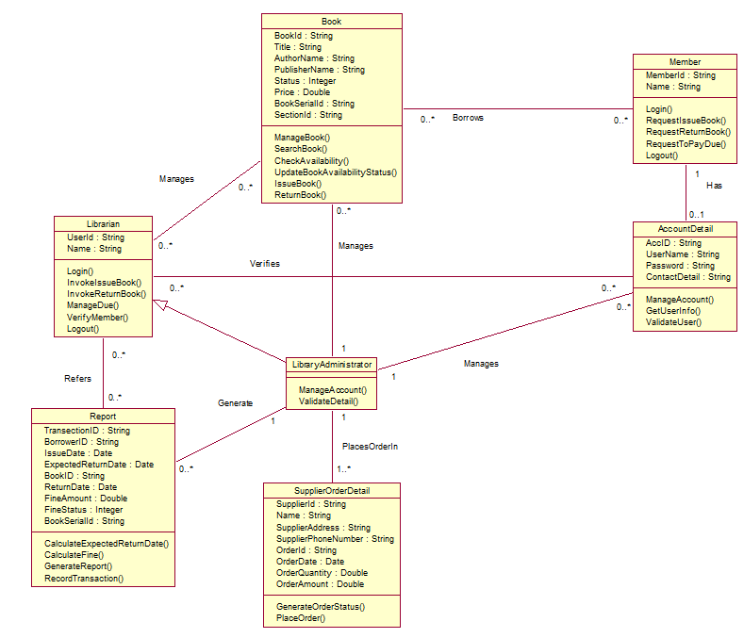

**Figure 4.2.1 Class Diagram**

a class diagram in the Unified Modeling Language (UML) is a type of static structure diagram that describes the structure of a system by showing the system's classes, their attributes, operations (or methods), and the relationships among objects. Class diagram for Library Management System is shown Figure 4.2.1. The various classes involved in the system are:

**Class**: Book, Member, Librarian, Library Administrator, Account Detail, Report and Supplier Order Detail

Here, in this system there could be three types of users: Member, Librarian and Library Administrator. Librarian and Library Administrator both use to share many of the properties and methods. So, we defined Librarian as base class and Library Administrator as derived class from it, so both class inherits properties and methods while Library administrator contains some additional properties and methods.

**4.3 SEQUENCE DIAGRAM**

A Sequence diagram is an interaction diagram that shows how processes operate with one another and in what order. It is a construct of a Message Sequence Chart. A sequence diagram shows object interactions arranged in time sequence.Here the sequence diagrams are constructed only for the successful cases and we assume that all the users who use LMS have login successfully before performing any of the following module.

**4.3.1 Login Module**

The sequence diagram drawn below explains the various messages passed between the objects when a user tries to login.

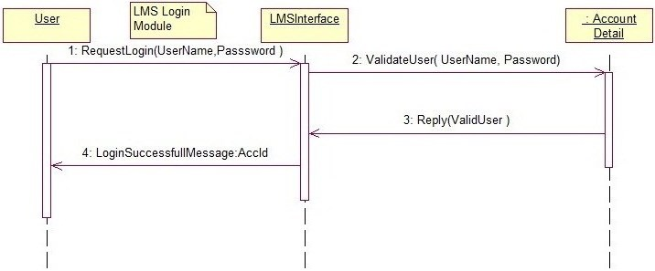

**Figure 4.3.1.1 Sequence Diagram for Login Module**

The sequence diagram drawn below explains the various messages passed between the objects when a user tries to logout.

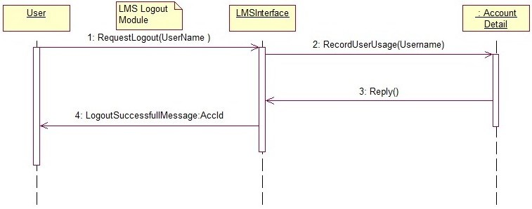

**Figure 4.3.1.2 Sequence Diagram for Logout Module**

**4.3.2 View Account Details Module**

The sequence diagram drawn below explains the various messages passed between the objects when a user tries to view the necessary information of his account.

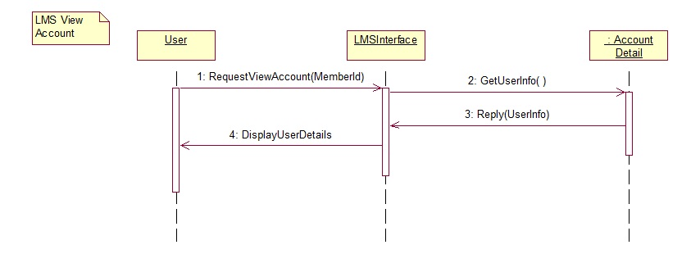

**Figure 4.3.2 Sequence Diagram for Viewing Account Details of User**

**4.3.3 Search Book Module**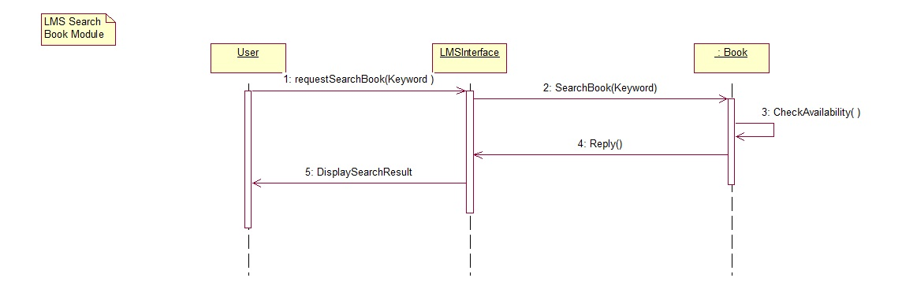

**Figure 4.3.3 Sequence Diagram for Search Book Module**

**4.3.4 Manage Book Record Module**

The sequence diagram drawn below explains the various messages passed between the objects when a user tries to add or delete or update the book details.

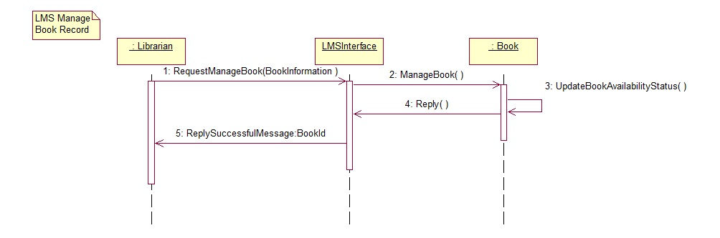

**Figure 4.3.4 Sequence Diagram for Manage Book Module**

**4.3.5 Issue Book Module**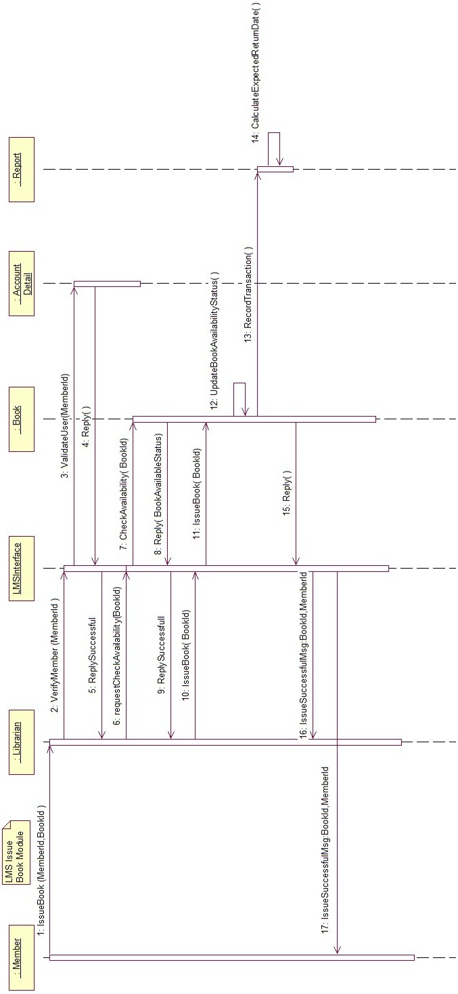

**Figure 4.3.4 Sequence Diagram for Issue Book Module**

**4.3.6 Return Book Module**

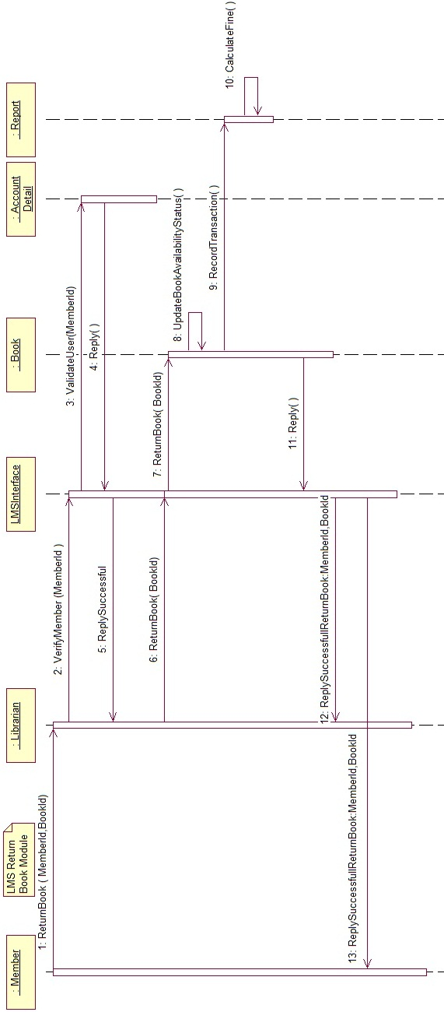

**Figure 4.3.6 Sequence Diagram for Return Book Module**

**4.3.7 Manage Due Module**

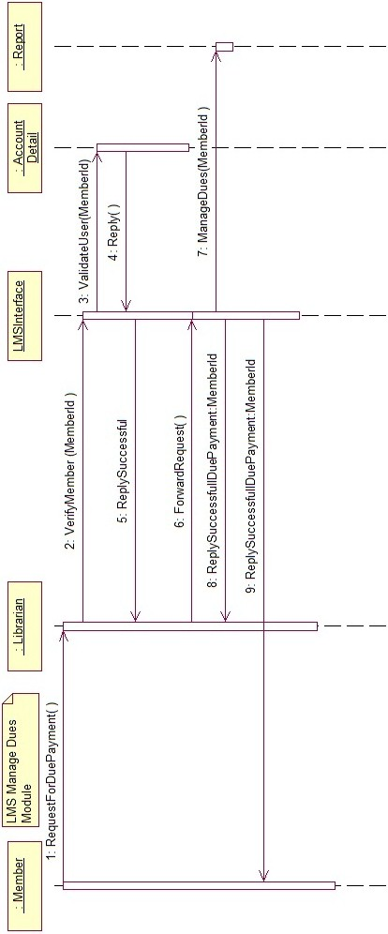

**Figure 4.3.7 Sequence Diagram for Manage Dues Module**

**4.3.8 Manage account Module**

The sequence diagram drawn below explains the various messages passed between the objects when a library administrator adds or deletes or updates the details of a member based on the request.

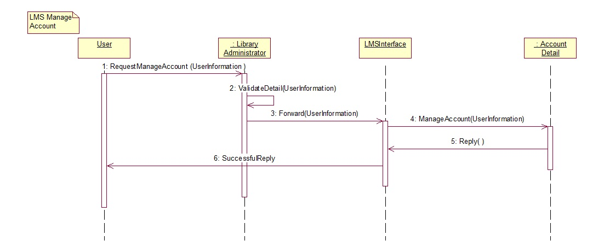**4.3.9 Report Generation Module**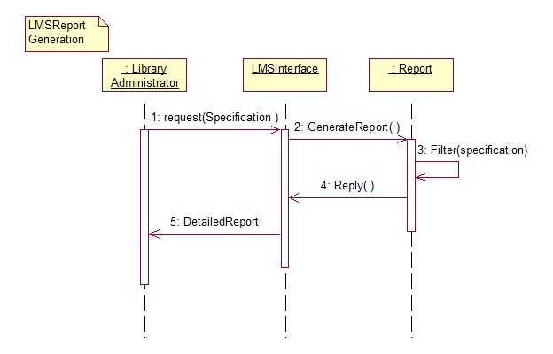

**Figure 4.3.9 Sequence Diagram for Report Generation Module**

**Figure 4.3.8 Sequence Diagram for Manage Account Module**

**4.3.10 Place Order Module**

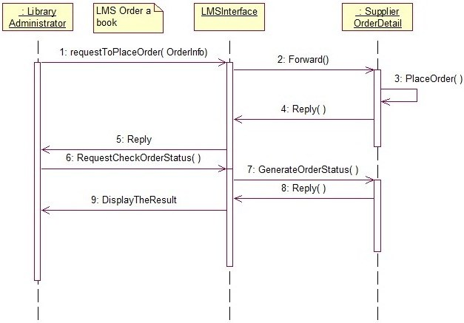

**Figure 4.3.10 Sequence Diagram for Place Order Module**

**4.4 ACTIVITY DIAGRAM**

Activity diagrams are graphical representations of workflows of stepwise activities and actions with support for choice, iteration and concurrency. In the Unified Modeling Language, activity diagrams are intended to model both computational and organisational processes

**4.4.1 Login Module**

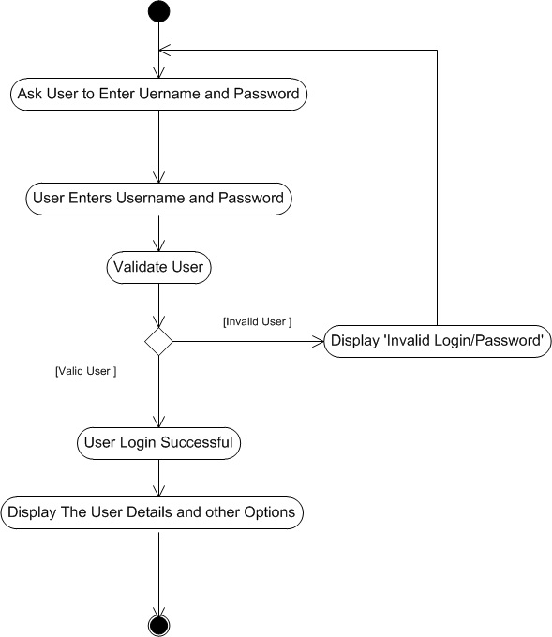

**Figure 4.4.1 Activity Diagram for Login Module**

**4.4.2 Search Book Module** 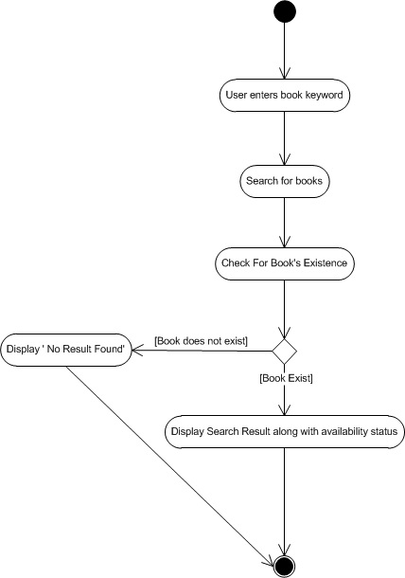

**Figure 4.4.2 Activity Diagram for Search Book Module**

**4.4.3 Manage Dues Module**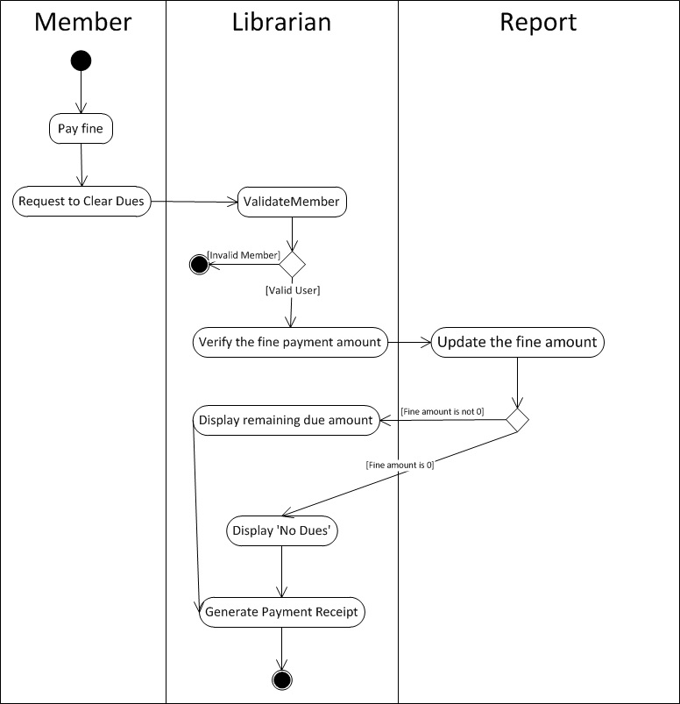

**Figure 4.4.3 Activity Diagram for Manage Dues Module**

**4.4.4 Manage Account Module**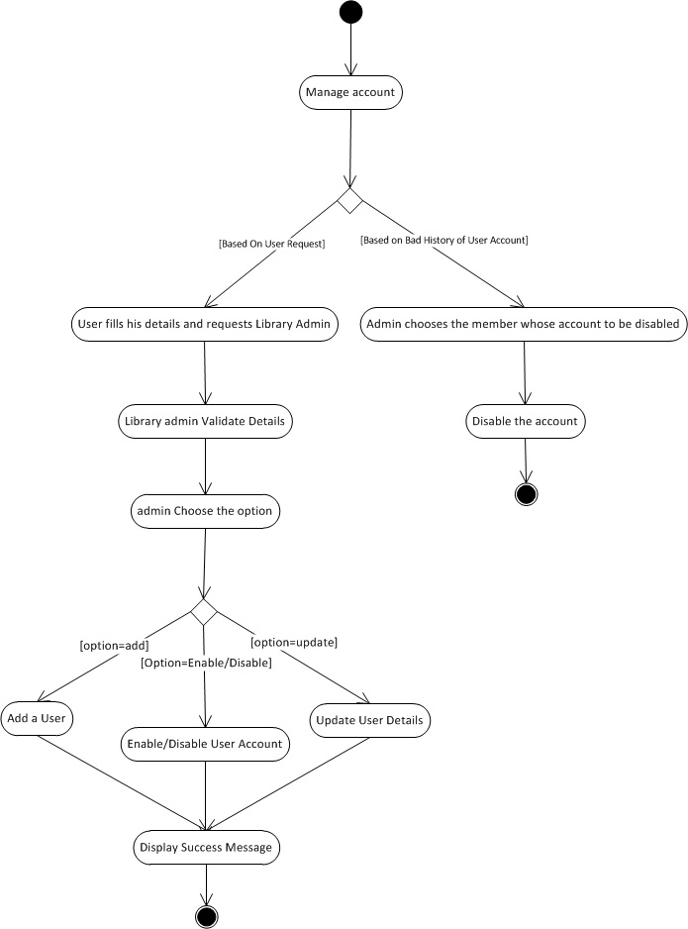

**Figure 4.4.4 Activity Diagram for Manage Account Module**

**4.4.5 Manage Book Record Module**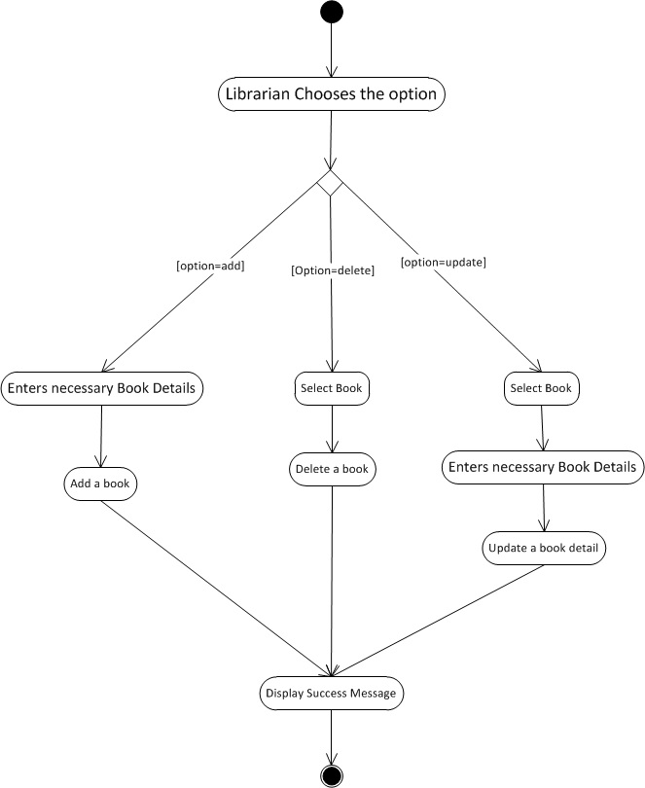

**Figure 4.4.5 Activity Diagram for Manage Book Record Module**

**4.4.6 Report Generation Module**

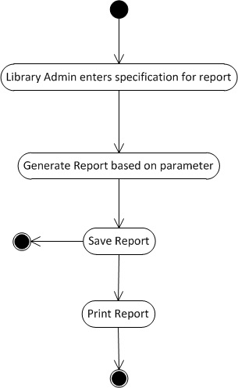

**Figure 4.4.6 Activity Diagram for Report Generation Module**

**4.4.7 Issue Book Module**

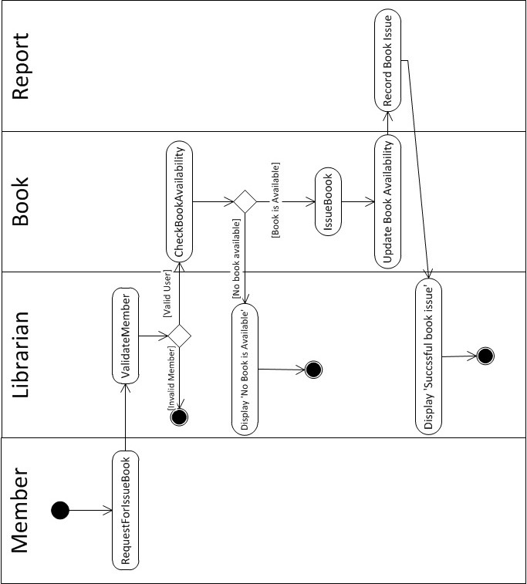

**Figure 4.4.7 Activity Diagram for Issue Book Module**

**4.4.8 Return Book Module**

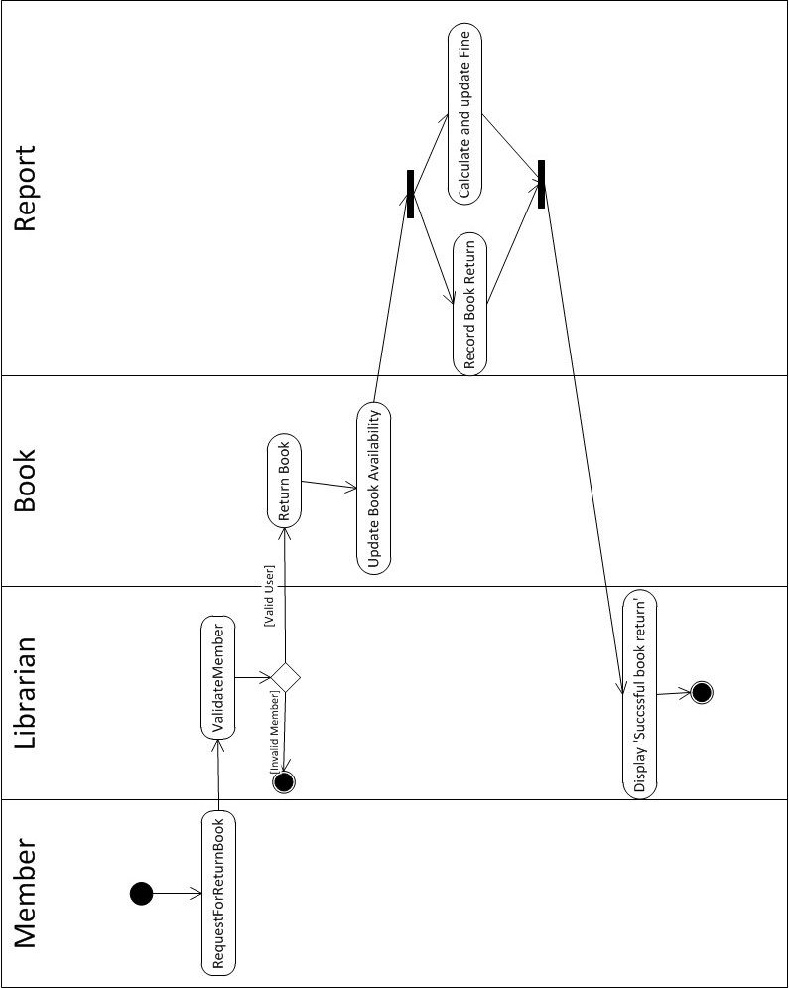

**Figure 4.4.8 Activity Diagram for Return Book Module**

**4.4.9 Place an Order for a Book Module**

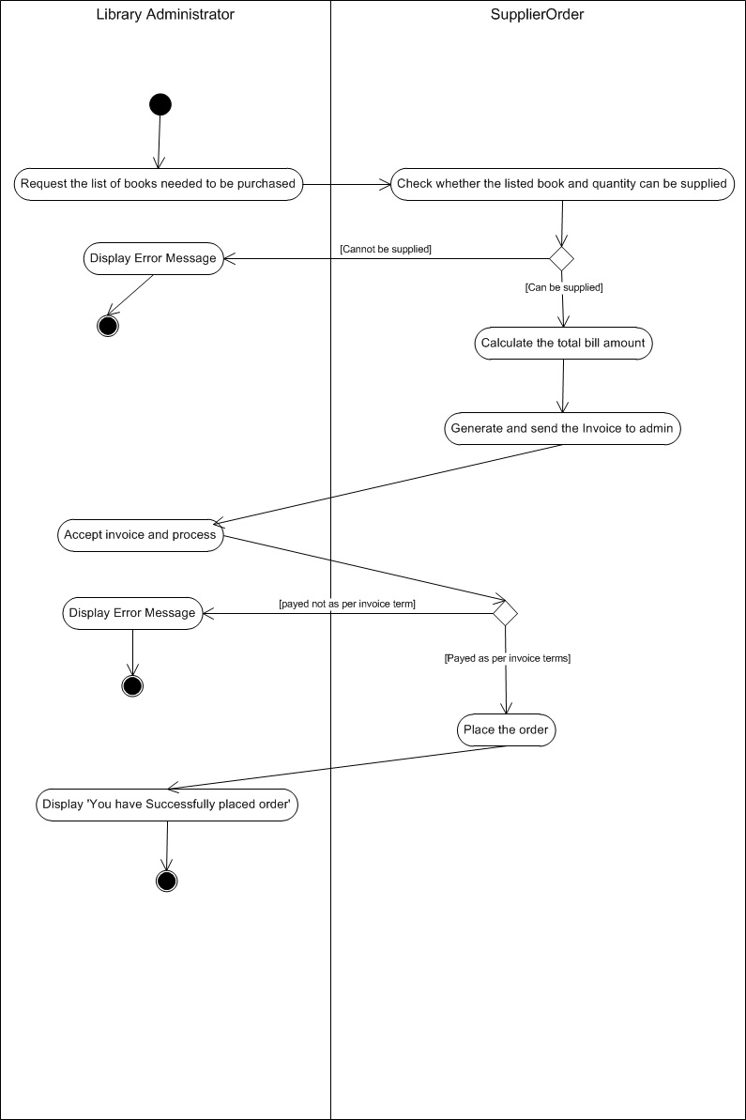

**Figure 4.4.9 Activity Diagram for Place an Order for Book Module**

**4.5 FINAL USECASE DIAGRAM**

A use case diagram at its simplest is a representation of a user's interaction with the system and depicting the specifications of a [use case](http://en.wikipedia.org/wiki/Use_Case). The various participants of the same are detailed below:

**Actors**: Member, Librarian, Administrator

The corresponding use cases for these actors are:

* Member: Request for Membership, Search Book, Request for Issue Book, Request for Book Return, Request to Pay Fine, View Account.
* Librarian: Search Book, Issue Book, Return Book, View Account, Manage Dues, Maintain Book Detail.
* Administrator: Search Book, Issue Book, Return Book, View Account, Manage Dues, Maintain Book Detail, Manage Order, Manage Account, Report Generation.

Here we have some dependencies as follows:

* Request for Managing Account <<include>> Fill the details.
* Search Book <<include>> Check Availability of Book.
* Issue Book <<include>> Check Availability of Book, Verify Member, Update Book Availability, Record Transaction.
* Return Book <<include>> Verify Member, Update Book Availability and Record Transaction.
* Manage Dues <<include>> Verify Member and Record Transaction.
* Maintain Book Details <<include>> Add Book Detail, Enable/Disable Book Detail and Update Book Detail.
* Manage Order <<include>> Place Order and Check Order Status.
* Manage Account <<include>> Add User, Enable/Disable User Account and Update User Detail.

The Use Case UML diagram for Library Management System is shown below:

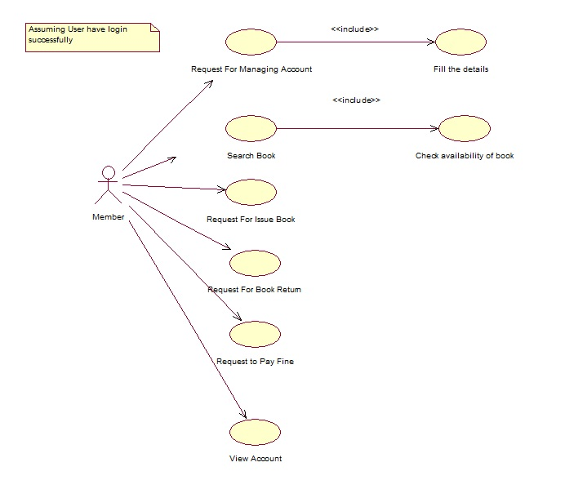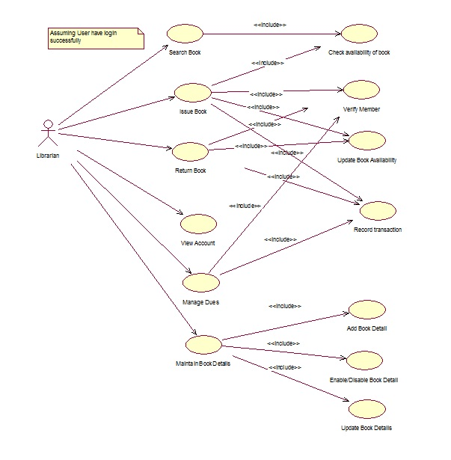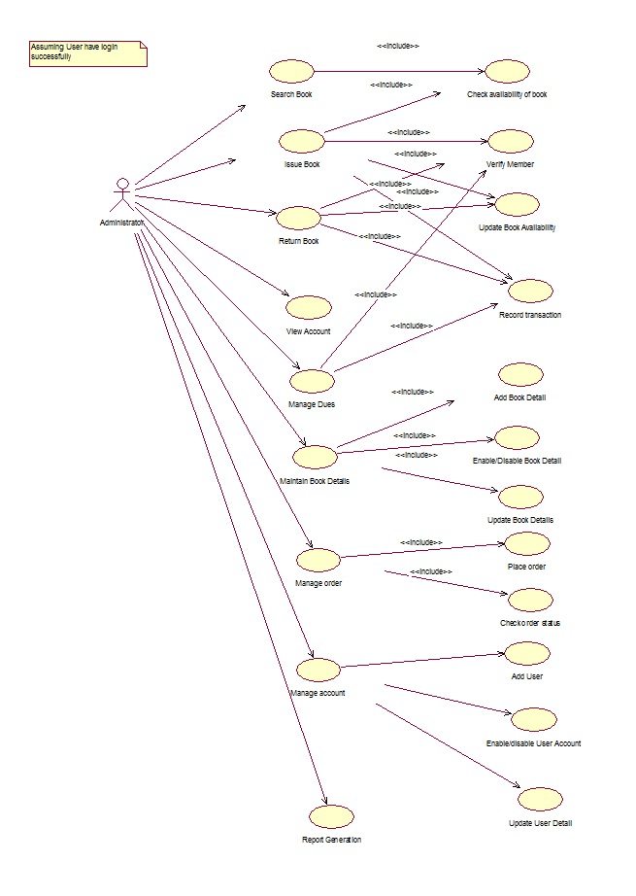

**4.5.1 Usecase Diagram of Member**

**Figure 4.5.1 Usecase Diagram for the actor Member**

**4.5.2 Usecase Diagram of Librarian**

**Figure 4.5.2 Usecase Diagram for the actor Librarian**

**4.5.3 Usecase Diagram of Library Administrator**

**Figure 4.5.3 Usecase Diagram for the actor Library Administrator**